Mike Cottrell College of Business

Department of Computer Science & Information Systems

CSCI 4950 – Senior Project

Bryan Hutto

**Assignment 4**

(Proposed Design)

The MusicScroller application is built to run on Windows 10. The procedure will perform the three key functions of image processing, data analysis, and scrolling.

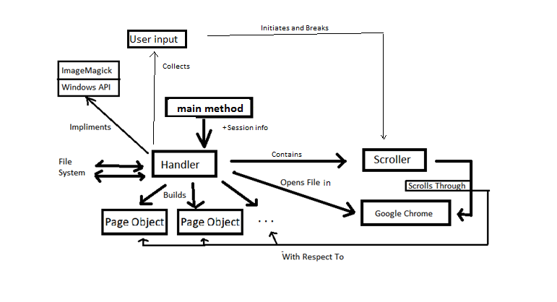

Figure 1 Simple Visualization of Program Structure

The application will take input from the user and then execute a controlled scroll on their selected document.

Document will be converted from PDF using the **Magick++ API** (ImageMagick).

Images will be rasterized and analyzed, data relevant to scroll are retrieved and stored in Page objects.

The document will be opened in **Google Chrome**. The **Windows API** will be used to execute scrolling on the Chrome window.

Inputs are saved in the Session object.